READINGS FOR SESSION 1

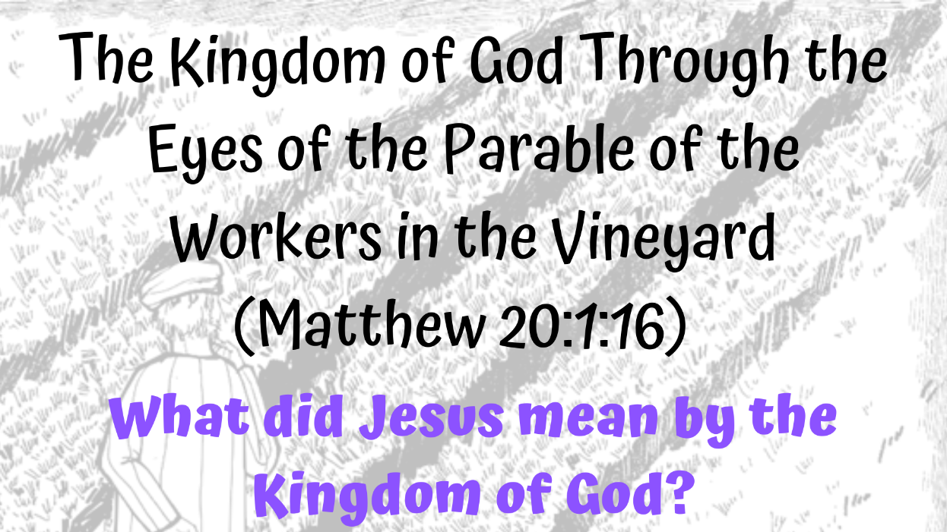

The Kingdom of God Through the Eyes of the Parables - What did Jesus mean by the Kingdom of God
ABOUT THIS STUDY
All information and downloads for the Zoom group study are available form www.spaceforfaith.co.uk/kingdom.
Additionally, there are two other methods of engagement
- A video version is available from www.spaceforfaith.co.uk/kingdom suitable for private individuals/small groups to study at home
- A Facebook group containing the video and a place for online discussion about the questions at www.facebook.com/groups/spaceforfaithbiblestudy

The Parable of the Workers in the Vineyard (Matthew 20:1-16)
20 “For the kingdom of heaven is like a landowner who went out early in the morning to hire workers for his vineyard. 2 He agreed to pay them a denarius[a] for the day and sent them into his vineyard.
3 “About nine in the morning he went out and saw others standing in the marketplace doing nothing. 4 He told them, ‘You also go and work in my vineyard, and I will pay you whatever is right.’ 5 So they went.
“He went out again about noon and about three in the afternoon and did the same thing. 6 About five in the afternoon he went out and found still others standing around. He asked them, ‘Why have you been standing here all day long doing nothing?’
7 “‘Because no one has hired us,’ they answered. “He said to them, ‘You also go and work in my vineyard.’
8 “When evening came, the owner of the vineyard said to his foreman, ‘Call the workers and pay them their wages, beginning with the last ones hired and going on to the first.’
9 “The workers who were hired about five in the afternoon came and each received a denarius. 10 So when those came who were hired first, they expected to receive more. But each one of them also received a denarius. 11 When they received it, they began to grumble against the landowner. 12 ‘These who were hired last worked only one hour,’ they said, ‘and you have made them equal to us who have borne the burden of the work and the heat of the day.’
13 “But he answered one of them, ‘I am not being unfair to you, friend. Didn’t you agree to work for a denarius? 14 Take your pay and go. I want to give the one who was hired last the same as I gave you. 15 Don’t I have the right to do what I want with my own money? Or are you envious because I am generous?’
16 “So the last will be first, and the first will be last.”

Additional Optional Reading
Barclay, William. Insights: Parables . (Hymns Ancient and Modern Ltd. 2011) Kindle Edition.
Barton J (Ed), Muddiman J (Ed), The Oxford Bible Commentary (Oxford University Press, Oxford, 2007)
Bibles, Harper. NRSV Bible with the Apocrypha. Zondervan. Kindle Edition.
Bible Project Podcast https://bibleproject.com/podcast/kingdom-god-part-1/ accessed 4 April 2022
Bible Project Podcast https://bibleproject.com/podcast/kingdom-god-part-2/ accessed 4 April 2022
Bible Project Podcast https://bibleproject.com/podcast/kingdom-god-part-3/ accessed 4 April 2022
Bible Project, Parables of Jesus, https://youtu.be/XX-aAg4_U2Q accessed 3 April 2022
Drane, John, Introducing the New Testament, Third Edition, (Lion Hudson, Oxford 2010)
Holy Bible, NIV New International Version, ( Hodder & Stoughton 2011) Kindle Edition.
MacArthur, John,The Mysteries of God’s Kingdom Revealed Through the Stories Jesus Told (Thomas Nelson 2015) Audible
Mackie, Tim, Jesus and the Kingdom of God [Matthew] - Tim Mackie (The Bible Project), https://youtu.be/yACigFnNKwg accessed 28 March 2022
Wright, N.T, Jesus and the People of God https://youtu.be/1AukgNlAgiI accessed 22 March 2022

